**FLIGHT PRICE PREDICTION**

*A*

*Theme Based Project Report Submitted in partial fulfillment ofthe*

*Requirements for the award of the Degree of*

## BACHELOR OF ENGINEERING

IN

## INFORMATION TECHNOLOGY

By

## <GOPI KRISHNA ><1602-19-737-071>

## <VISHWA TEJA ><1602-20-737-119>

**<TEJA ><1602-20-737-115>**



## Department of Information Technology Vasavi College of Engineering (Autonomous)

**VASAVI COLLEGE OF ENGINEERING (AUTONOMOUS)**

### (AFFILIATED TO OSMANIA UNIVERSITY) HYDERABAD - 500 030

**Department of Information Technology**



### DECLARATION BY CANDIDATE

We, **<GOPI KRISHNA >, <VISHWA TEJA>, <TEJA >,** bearing hall ticket number, **<1602-19-737-071>, <1602-20-737-119>, <1602-20-737-115**>

hereby declare that the project report entitled **<” FLIGHT PRICE PREDICTION”>** Department of Information Technology, Vasavi College of Engineering, Hyderabad, is submitted in partial fulfillment of the requirement for the award of the degree of **Bachelor of Engineering** in **Information Technology**

This is a record of bona-fide work carried out by me and the results embodied in this project report has not been submitted to any other university or institute for the award of any other degree or diploma.

### <GOPI KRISHNA ><1602-19-737-071>

**<VISHWA TEJA ><1602-20-737-119>**

**<TEJA><1602-20-737-115>**

## VASAVI COLLEGE OF ENGINEERING (AUTONOMOUS)

### (AFFILIATED TO OSMANIA UNIVERSITY) HYDERABAD - 500 030

**Department of Information Technology**



### BONAFIDE CERTIFICATE

This is to certify that the project entitled “**FLIGHT PRICE PREDICTION**” being submitted by GOPI KRISHNA, VISHWA TEJA, TEJA bearing 1602-19-737-071,1602-20-737-119,**1602-20-737-115**, in partial fulfillment of the requirements for the completion of THEME BASED PROJECT of Bachelor of Engineering in Information Technology is a record of bona-fide work carried out by them under my guidance.

Internal Guide External Examiner Dr. K Ram Mohan Rao Mr. Dharma Reddy

Ms. Kezia Rani HOD, IT

## ACKNOWLEDGEMENT

We thank the department of INFORMATION TECHNOLOGY, for introducing the subject “Theme Based Project” in BE sixth semester.

We would also like to show our appreciation to our Honorable principal, Dr S V Ramana sir, our HOD K. Ram Mohan Rao for supporting us and our mini project lecturer, Mr. Dharma Reddy and Ms. Kezia Rani, for letting us properly understand the process of doing a project and for providing valuable insight and expertise that has greatly assisted us in the making of the project.

**TABLE OF CONTENTS**

|  |  |
| --- | --- |
| Topic | Page No. |
| Introduction | 6 |
| Technology | 7 |
| Design | 8 |
| Implementation | 15 |
| Testing | 24 |
| Additional Knowledge Acquired | 33 |
| Conclusion and Future work | 34 |
| References | 35 |

|  |
| --- |
| S.No |
| 1. |
| 2. |
| 3. |
| 4. |
| 5. |
| 6. |
| 7. |
| 8. |

**ABSTRACT**

People who frequently travel through flight will have better knowledge on best discount and right time to buy the ticket. For the business purpose many airline companies change prices according to the seasons or time duration. They will increase the price when people travel more. Estimating the highest prices of the airlines data for the route is collected with features such as Duration, Source, Destination, Arrival, Departure. Features are taken from chosen dataset and in this paper, we have used machine learning techniques and regression strategies for prediction of the price wherein the airline price ticket costs vary overtime. We have implemented flight price prediction for users by using decision tree and random forest algorithms.

# INTRODUCTION

# For purchasing an airplane ticket, the traditional purchase strategy is to buy a ticket far in advance of the flight’s departure date to avoid the risk that the price may increase rapidly before the departure date. However, this is usually not always true, airplane companies can decrease the prices if they want to increase the sales.

# Airline companies use many different variables to determine the flight ticket prices that indicates whether the travel is during the holidays, the number of free seats in the plane etc., or even in which month it is, some of the variables are observed, but some of them are hidden.

# In this context, buyers are trying to find the right day to buy the ticket, and on the contrary, the airplane companies are trying to keep the overall revenue as high as possible. Airline companies have the freedom to change the flight ticket prices at any moment. Travellers can save money if they choose to buy a ticket when its price is the lowest.

# PURPOSE

# The goal of this project is to study how airline ticket prices change over time, extract the factors that influence these fluctuations, and describe how they're correlated. A machine learning framework was developed to predict the quarterly average airfare price at the market segment level. Several features were extracted from the datasets and combined with macroeconomic data, to model the air travel market segments. With the help of the feature assortment methods, our proposed model can forecast the quarterly average airfare price with an adjustment. The cheapest available ticket for a given date gets more or less expensive over time.

# The project implements is the validations or contradictions towards myths regarding the airline industry, a comparison study among various models in predicting the optimal time to buy the flight ticket and the amount that can be saved if done so, A customized model which included [8] a combination of ensemble and statistical models have been implemented with the best accuracy of above 90% for a few routes, mostly from Tier to metro cities [7]. These models have led to substantial savings and formed average positive savings on every transaction.

## INTENDED AUDIENCE

The intended audiences for this project are the people who travel through airlines.

As flight prices fluctuate unpredictably it is financially heavy burden for the daily customers.

## PRODUCT SCOPE

Now we have designed a basic website. We are planning to increase the complexity of front-end using CSS, HTML and JAVASCRIPT. We also want to study the machine learning algorithms we used in the current project and make it more efficient in the coming semester.

## PROBLEM DEFINITION

Nowadays, the airline corporations are using complex strategies for the flight ticket fare calculations. This highly complicated method makes the flight ticket fare difficult to guess for the customers, since the fare changes dynamically.

Our project “**Flight Price Prediction System”** which resolves this problem and will provide a facility where people will be able to predict the flight-ticket price before purchasing the ticket.

# CHAPTER 2 RELATED WORK

# RavelSaathi is an AI-enabled Web Platform-based application. It serves as the day-to-day companion for Airport Authority individuals. It can be useful for both aviation professionals and their customers. They can intelligently set the Fare price of flight tickets, can compare with competitive industries, and can also provide environmentally friendly and energy-saving solutions.

# They can intelligently set the Fare price of flight tickets, can compare with competitive industries, and can also provide environmentally friendly and energy-saving solutions. More specifically, this system is designed to allow the Aviation industry to set competitive fare prices for their Flight service and obtain beneficiary margins;along with monitoring Airport premises and conserving Energy.

# These days, Python is covering almost all aspects of the IT industry Software production. HTML, CSS, and JavaScript have been used for the front-end UI interface and back-end connectivity has been handled by PHP language. Flask has been used for API building, and Wamp Server to host WEB APP on local windows PC.

# CHAPTER 3

# PROPOSED WORK –

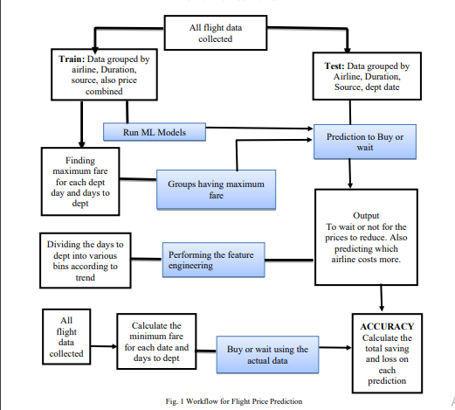

# UI prototypes or screenshots

# 

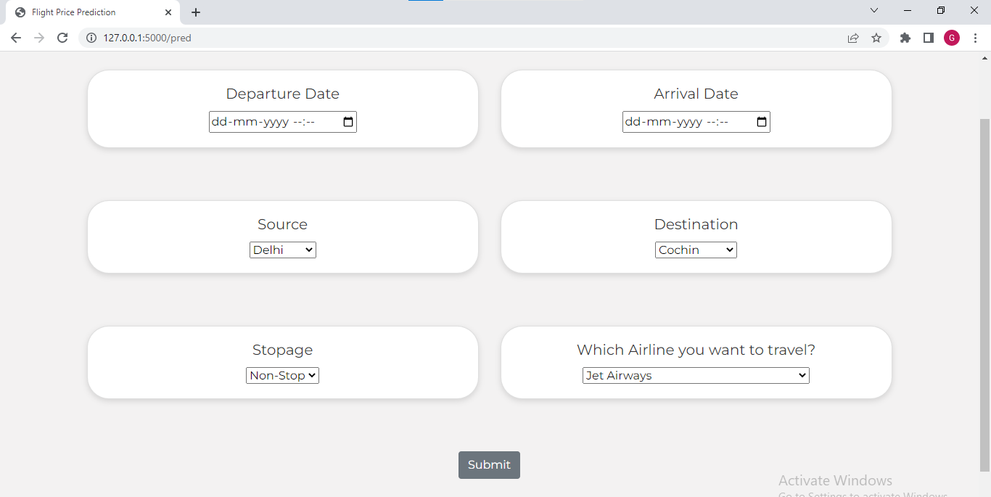



**Architecture and Technology used –**

Technology used –

Front-end: HTML, CSS, Flask

Back-end Modules used: Matplotlib, Machine Learning (Supervised learning).

Machine Learning (Supervised learning): Supervised learning is a process of providing input data as well as correct output data to the machine learning model. The aim of a supervised learning algorithm is to **find a mapping function to map the input variable(x) with the output variable(y)**. In the real-world, supervised learning can be used for **Risk Assessment, Image classification, Fraud Detection, spam filtering**, etc.

**Matplotlib**: Matplotlib is a plotting library for the Python programming language and its numerical mathematics extension NumPy. It provides an object-oriented API for embedding plots into applications using general- purpose GUI toolkits like Tkinter, wxPython, Qt, or GTK. There is also a procedural "pylab" interface based on a state machine (like OpenGL), designed to closely resemble that of MATLAB, though its use is discouraged. SciPy makes use of Matplotlib.

**Random Forest Algorithm**: One of the popular machine learning algorithms which belongs to the supervised learning technique is Random Forest. Process of combining multiple classifiers to solve complicated problem and increasing the performance of the model it is based on the concept of learning. To avoid the overfitting problem and the greater number of trees in the forest tends to greater accuracy. Random forest is used for both classification and regression problems is the huge advantage.

**Use-case diagram**: 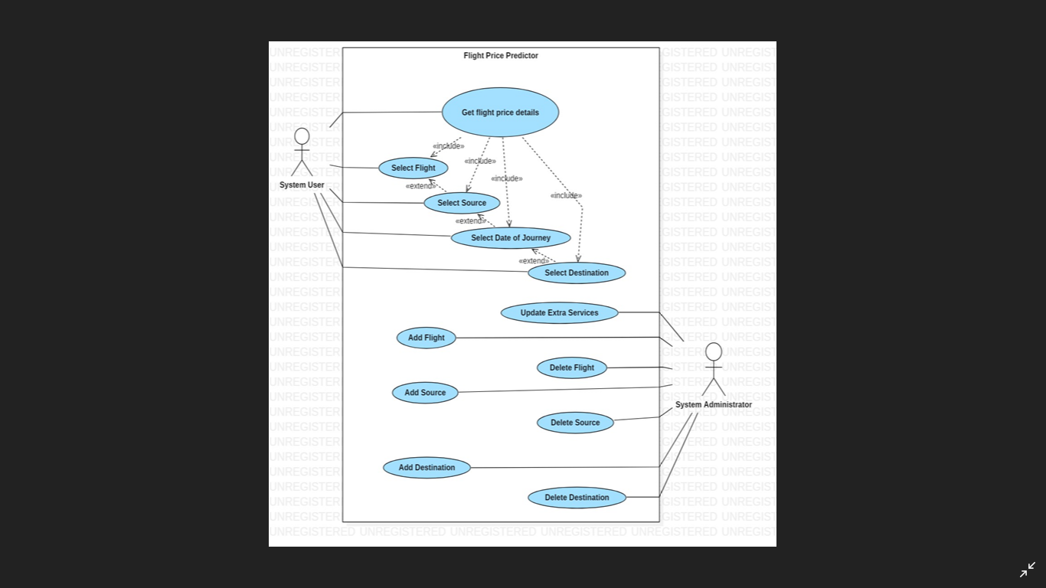

**FEATURES**:

Airline: The name of the airline.

Date_of_Journey: The date of the journey

Source: The source from which the service begins.

Destination: The destination where the service ends.

Route: The route was taken by the flight to reach the destination.

Dep_Time: The time when the journey starts from the source.

Arrival_Time: Time of arrival at the destination.

Duration: Total duration of the flight.

Total_Stops: Total stops between the source and destination.

Additional_Info: Additional information about the flight.

Price:Thepriceoftheticket

# USE CASE 01:

# SELECT FLIGHT: The flight company the user want to travel .

# USE CASE 02:

# SELECT DATE AND TIME OF THE JOUNEY: The user will give the time and date of the start and he will provide the destination date and time.

# USE CASE 03:

# SELECT SOURCE: The user will select the source information from which the user will start the journey.

# USE CASE 04:

# SELECT DESTINATION : The user will select the destination information .

# USE CASE 05:

# GET PRICE DETAILS: By submitting the required details, the user will get the flight price details.

# Design –

### DATA FLOW DIAGRAM:

### 

# Implementation-

# app.py

# code:

from flask import Flask, request, render_template

from flask_cors import cross_origin

import sklearn

import pickle

import pandas as pd

app = Flask(__name__)

model = pickle.load(open("flight_rf.pkl", "rb"))

@app.route("/")

@cross_origin()

def home():

    return render_template("index.html")

@app.route("/pred")

@cross_origin()

def index():

    return render_template("Predict.html")

@app.route("/predict", methods = ["GET", "POST"])

@cross_origin()

def predict():

    if request.method == "POST":

        # Date_of_Journey

        date_dep = request.form["Dep_Time"]

        Journey_day = int(pd.to_datetime(date_dep, format="%Y-%m-%dT%H:%M").day)

        Journey_month = int(pd.to_datetime(date_dep, format ="%Y-%m-%dT%H:%M").month)

        # print("Journey Date : ",Journey_day, Journey_month)

        # Departure

        Dep_hour = int(pd.to_datetime(date_dep, format ="%Y-%m-%dT%H:%M").hour)

        Dep_min = int(pd.to_datetime(date_dep, format ="%Y-%m-%dT%H:%M").minute)

        # print("Departure : ",Dep_hour, Dep_min)

        # Arrival

        date_arr = request.form["Arrival_Time"]

        Arrival_hour = int(pd.to_datetime(date_arr, format ="%Y-%m-%dT%H:%M").hour)

        Arrival_min = int(pd.to_datetime(date_arr, format ="%Y-%m-%dT%H:%M").minute)

        # print("Arrival : ", Arrival_hour, Arrival_min)

        # Duration

        dur_hour = abs(Arrival_hour - Dep_hour)

        dur_min = abs(Arrival_min - Dep_min)

        # print("Duration : ", dur_hour, dur_min)

        # Total Stops

        Total_stops = int(request.form["stops"])

        # print(Total_stops)

        # Airline

        # AIR ASIA = 0 (not in column)

        airline=request.form['airline']

        if(airline=='Jet Airways'):

            Jet_Airways = 1

            IndiGo = 0

            Air_India = 0

            Multiple_carriers = 0

            SpiceJet = 0

            Vistara = 0

            GoAir = 0

            Multiple_carriers_Premium_economy = 0

            Jet_Airways_Business = 0

            Vistara_Premium_economy = 0

            Trujet = 0

        elif (airline=='IndiGo'):

            Jet_Airways = 0

            IndiGo = 1

            Air_India = 0

            Multiple_carriers = 0

            SpiceJet = 0

            Vistara = 0

            GoAir = 0

            Multiple_carriers_Premium_economy = 0

            Jet_Airways_Business = 0

            Vistara_Premium_economy = 0

            Trujet = 0

        elif (airline=='Air India'):

            Jet_Airways = 0

            IndiGo = 0

            Air_India = 1

            Multiple_carriers = 0

            SpiceJet = 0

            Vistara = 0

            GoAir = 0

            Multiple_carriers_Premium_economy = 0

            Jet_Airways_Business = 0

            Vistara_Premium_economy = 0

            Trujet = 0

        elif (airline=='Multiple carriers'):

            Jet_Airways = 0

            IndiGo = 0

            Air_India = 0

            Multiple_carriers = 1

            SpiceJet = 0

            Vistara = 0

            GoAir = 0

            Multiple_carriers_Premium_economy = 0

            Jet_Airways_Business = 0

            Vistara_Premium_economy = 0

            Trujet = 0

        elif (airline=='SpiceJet'):

            Jet_Airways = 0

            IndiGo = 0

            Air_India = 0

            Multiple_carriers = 0

            SpiceJet = 1

            Vistara = 0

            GoAir = 0

            Multiple_carriers_Premium_economy = 0

            Jet_Airways_Business = 0

            Vistara_Premium_economy = 0

            Trujet = 0

        elif (airline=='Vistara'):

            Jet_Airways = 0

            IndiGo = 0

            Air_India = 0

            Multiple_carriers = 0

            SpiceJet = 0

            Vistara = 1

            GoAir = 0

            Multiple_carriers_Premium_economy = 0

            Jet_Airways_Business = 0

            Vistara_Premium_economy = 0

            Trujet = 0

        elif (airline=='GoAir'):

            Jet_Airways = 0

            IndiGo = 0

            Air_India = 0

            Multiple_carriers = 0

            SpiceJet = 0

            Vistara = 0

            GoAir = 1

            Multiple_carriers_Premium_economy = 0

            Jet_Airways_Business = 0

            Vistara_Premium_economy = 0

            Trujet = 0

        elif (airline=='Multiple carriers Premium economy'):

            Jet_Airways = 0

            IndiGo = 0

            Air_India = 0

            Multiple_carriers = 0

            SpiceJet = 0

            Vistara = 0

            GoAir = 0

            Multiple_carriers_Premium_economy = 1

            Jet_Airways_Business = 0

            Vistara_Premium_economy = 0

            Trujet = 0

        elif (airline=='Jet Airways Business'):

            Jet_Airways = 0

            IndiGo = 0

            Air_India = 0

            Multiple_carriers = 0

            SpiceJet = 0

            Vistara = 0

            GoAir = 0

            Multiple_carriers_Premium_economy = 0

            Jet_Airways_Business = 1

            Vistara_Premium_economy = 0

            Trujet = 0

        elif (airline=='Vistara Premium economy'):

            Jet_Airways = 0

            IndiGo = 0

            Air_India = 0

            Multiple_carriers = 0

            SpiceJet = 0

            Vistara = 0

            GoAir = 0

            Multiple_carriers_Premium_economy = 0

            Jet_Airways_Business = 0

            Vistara_Premium_economy = 1

            Trujet = 0

        elif (airline=='Trujet'):

            Jet_Airways = 0

            IndiGo = 0

            Air_India = 0

            Multiple_carriers = 0

            SpiceJet = 0

            Vistara = 0

            GoAir = 0

            Multiple_carriers_Premium_economy = 0

            Jet_Airways_Business = 0

            Vistara_Premium_economy = 0

            Trujet = 1

        else:

            Jet_Airways = 0

            IndiGo = 0

            Air_India = 0

            Multiple_carriers = 0

            SpiceJet = 0

            Vistara = 0

            GoAir = 0

            Multiple_carriers_Premium_economy = 0

            Jet_Airways_Business = 0

            Vistara_Premium_economy = 0

            Trujet = 0

        # print(Jet_Airways,

        #     IndiGo,

        #     Air_India,

        #     Multiple_carriers,

        #     SpiceJet,

        #     Vistara,

        #     GoAir,

        #     Multiple_carriers_Premium_economy,

        #     Jet_Airways_Business,

        #     Vistara_Premium_economy,

        #     Trujet)

        # Source

        # Banglore = 0 (not in column)

        Source = request.form["Source"]

        if (Source == 'Delhi'):

            s_Delhi = 1

            s_Kolkata = 0

            s_Mumbai = 0

            s_Chennai = 0

        elif (Source == 'Kolkata'):

            s_Delhi = 0

            s_Kolkata = 1

            s_Mumbai = 0

            s_Chennai = 0

        elif (Source == 'Mumbai'):

            s_Delhi = 0

            s_Kolkata = 0

            s_Mumbai = 1

            s_Chennai = 0

        elif (Source == 'Chennai'):

            s_Delhi = 0

            s_Kolkata = 0

            s_Mumbai = 0

            s_Chennai = 1

        else:

            s_Delhi = 0

            s_Kolkata = 0

            s_Mumbai = 0

            s_Chennai = 0

        # print(s_Delhi,

        #     s_Kolkata,

        #     s_Mumbai,

        #     s_Chennai)

        # Destination

        # Banglore = 0 (not in column)

        Destination = request.form["Destination"]

        if (Destination == 'Cochin'):

            d_Cochin = 1

            d_Delhi = 0

            d_New_Delhi = 0

            d_Hyderabad = 0

            d_Kolkata = 0

        elif (Destination == 'Delhi'):

            d_Cochin = 0

            d_Delhi = 1

            d_New_Delhi = 0

            d_Hyderabad = 0

            d_Kolkata = 0

        elif (Destination == 'New_Delhi'):

            d_Cochin = 0

            d_Delhi = 0

            d_New_Delhi = 1

            d_Hyderabad = 0

            d_Kolkata = 0

        elif (Destination == 'Hyderabad'):

            d_Cochin = 0

            d_Delhi = 0

            d_New_Delhi = 0

            d_Hyderabad = 1

            d_Kolkata = 0

        elif (Destination == 'Kolkata'):

            d_Cochin = 0

            d_Delhi = 0

            d_New_Delhi = 0

            d_Hyderabad = 0

            d_Kolkata = 1

        else:

            d_Cochin = 0

            d_Delhi = 0

            d_New_Delhi = 0

            d_Hyderabad = 0

            d_Kolkata = 0

        # print(

        #     d_Cochin,

        #     d_Delhi,

        #     d_New_Delhi,

        #     d_Hyderabad,

        #     d_Kolkata

        # )

    #     ['Total_Stops', 'Journey_day', 'Journey_month', 'Dep_hour',

    #    'Dep_min', 'Arrival_hour', 'Arrival_min', 'Duration_hours',

    #    'Duration_mins', 'Airline_Air India', 'Airline_GoAir', 'Airline_IndiGo',

    #    'Airline_Jet Airways', 'Airline_Jet Airways Business',

    #    'Airline_Multiple carriers',

    #    'Airline_Multiple carriers Premium economy', 'Airline_SpiceJet',

    #    'Airline_Trujet', 'Airline_Vistara', 'Airline_Vistara Premium economy',

    #    'Source_Chennai', 'Source_Delhi', 'Source_Kolkata', 'Source_Mumbai',

    #    'Destination_Cochin', 'Destination_Delhi', 'Destination_Hyderabad',

    #    'Destination_Kolkata', 'Destination_New Delhi']

        prediction=model.predict([[

            Total_stops,

            Journey_day,

            Journey_month,

            Dep_hour,

            Dep_min,

            Arrival_hour,

            Arrival_min,

            dur_hour,

            dur_min,

            Air_India,

            GoAir,

            IndiGo,

            Jet_Airways,

            Jet_Airways_Business,

            Multiple_carriers,

            Multiple_carriers_Premium_economy,

            SpiceJet,

            Trujet,

            Vistara,

            Vistara_Premium_economy,

            s_Chennai,

            s_Delhi,

            s_Kolkata,

            s_Mumbai,

            d_Cochin,

            d_Delhi,

            d_Hyderabad,

            d_Kolkata,

            d_New_Delhi

        ]])

        output=round(prediction[0],2)

        return render_template('Predict.html',prediction_text="Your Flight price is Rs. {}".format(output))

    return render_template("Predict.html")

if __name__ == "__main__":

    app.run(debug=True)

styles.css

code:

@import url('https://fonts.googleapis.com/css2?family=Montserrat:wght@400&display=swap');

body {

    background-color: #f3f2f2;

    text-align: center;

    font-family: 'Montserrat', sans-serif;

}

.navbar {

    background-color: #333333;

}

a {

    color: #f1f9f9;

}

a:hover {

    color: #f0f0f0;

    font-style: bold;

  }

.cardInput {

    color : #333333;

    /* background-color: #e1f4f3; */

    background-color: white;

    border-radius: 30px;

    box-shadow: 0 3px 8px rgba(40, 39, 39, 0.15);

}

.carousel {

    height : "400px"; width:"400px";

}

.head1{

    color: rgb(59, 59, 59);

    align-items: center;

}

.head5{

    font-size: 1.2rem;

    color: rgb(59, 59, 59);

    align-items: center;

}

.cardBox {

    display: flex;

    flex-direction:row;

    justify-content: space-between;

}

footer {

    /* display: flex; */

    /* flex-direction:row; */

    height: 30px;

    align-items: center;

    color: white;

    background-color: #333333;

}

Index.html

Code:

<html lang="en">

<head>

    <meta charset="UTF-8">

    <meta name="viewport" content="width=device-width, initial-scale=1.0">

    <title>Flight Insights</title>

    <!-- BootStrap -->

    <link rel="stylesheet" href="https://stackpath.bootstrapcdn.com/bootstrap/4.5.0/css/bootstrap.min.css"

        integrity="sha384-9aIt2nRpC12Uk9gS9baDl411NQApFmC26EwAOH8WgZl5MYYxFfc+NcPb1dKGj7Sk" crossorigin="anonymous">

    <!-- css -->

    <link rel="stylesheet" href="static/css/styles.css">

</head>

<body>

    <!-- As a heading -->

    <nav class="navbar navbar-inverse navbar-fixed-top">

        <div class="container-fluid">

            <div class="navbar-header">

                <a class="navbar-brand" href="/">FLIGHT INSIGHTS</a>

                <a class="navbar-brand" href="/pred">PREDICTOR</a>

            </div>

        </div>

    </nav>

    <div class="bgImg">

        <img id="flight" src="{{url_for('static',filename='/Images/Flight.jpg')}}" alt = "flight" width = "100%" height = "500px" />

    </div>

    <br/>

    <h1 class = "head1">Get Insights about various Flights and Prices</h1>

    <p class="head5">Get Price Prediction of various Flight Prices throught our Machine Learning Model</p>

    <br/>

    <div class = "container cardBox">

        <div class="card" style="width: 18rem;">

            <img class="card-img-top" src="{{url_for('static',filename='/Images/C1.jpg')}}" alt="Card image cap">

        <div class="card-body">

          <p class="card-text">We provide information about various airlines and flights at the comfort of fingertips.</p>

        </div>

      </div>

      <div class="card" style="width: 18rem;">

        <img class="card-img-top" src="{{url_for('static',filename='/Images/c2.jpg')}}" alt="Card image cap">

        <div class="card-body">

          <p class="card-text">Predict Future Prices of different airlines from one Source to Destination with our Machine Learning Model</p>

        </div>

      </div>

      <div class="card" style="width: 18rem;">

        <img class="card-img-top" src="{{url_for('static',filename='/Images/C3.jpg')}}" alt="Card image cap">

        <div class="card-body">

          <p class="card-text">Contact Us for any query through a simple click and you'll have an instant response from Us</p>

        </div>

      </div>

    </div>

    <br/><br/>

    <div>

        <!-- <img id="flight" src="{{url_for('static',filename='/Images/Plane.jpg')}}" alt = "flight" width = "100%" height = "550px" /> -->

    </div>

    <br>

        <br>

        <footer>

            <p>©2022 Yash Bhanushali & Khaleequr Rehman. All Rights Reserved</p>

        </footer>

    <!-- JavaScript -->

    <script src="https://code.jquery.com/jquery-3.5.1.slim.min.js"

        integrity="sha384-DfXdz2htPH0lsSSs5nCTpuj/zy4C+OGpamoFVy38MVBnE+IbbVYUew+OrCXaRkfj"

        crossorigin="anonymous"></script>

    <script src="https://cdn.jsdelivr.net/npm/popper.js@1.16.0/dist/umd/popper.min.js"

        integrity="sha384-Q6E9RHvbIyZFJoft+2mJbHaEWldlvI9IOYy5n3zV9zzTtmI3UksdQRVvoxMfooAo"

        crossorigin="anonymous"></script>

    <script src="https://stackpath.bootstrapcdn.com/bootstrap/4.5.0/js/bootstrap.min.js"

        integrity="sha384-OgVRvuATP1z7JjHLkuOU7Xw704+h835Lr+6QL9UvYjZE3Ipu6Tp75j7Bh/kR0JKI"

        crossorigin="anonymous"></script>

</body>

</html>

**Predict.html**

**Code:**

<html lang="en">

<head>

    <meta charset="UTF-8">

    <meta name="viewport" content="width=device-width, initial-scale=1.0">

    <title>Flight Price Prediction</title>

    <!-- BootStrap -->

    <link rel="stylesheet" href="https://stackpath.bootstrapcdn.com/bootstrap/4.5.0/css/bootstrap.min.css"

        integrity="sha384-9aIt2nRpC12Uk9gS9baDl411NQApFmC26EwAOH8WgZl5MYYxFfc+NcPb1dKGj7Sk" crossorigin="anonymous">

    <!-- css -->

    <link rel="stylesheet" href="static/css/styles.css">

</head>

<body>

    <!-- As a heading -->

    <nav class="navbar navbar-inverse navbar-fixed-top">

        <div class="container-fluid">

            <div class="navbar-header">

                <a class="navbar-brand" href="/">FLIGHT INSIGHTS</a>

                <a class="navbar-brand" href="/pred">PREDICTOR</a>

            </div>

        </div>

    </nav>

    <br><br><br>

    <div class="container">

        <form action="\predict" method="post">

            <div class="row">

                <div class="col-sm-6">

                    <div class="card cardInput">

                        <div class="card-body">

                            <h5 class="card-title">Departure Date</h5>

                            <!-- Departure -->

                            <input type="datetime-local" name="Dep_Time" id="Dep_Time" required="required">

                        </div>

                    </div>

                </div>

                <br>

                <br>

                <br>

                <div class="col-sm-6">

                    <div class="card cardInput">

                        <div class="card-body">

                            <h5 class="card-title">Arrival Date</h5>

                            <!-- Arrival -->

                            <input type="datetime-local" name="Arrival_Time" id="Arrival_Time" required="required">

                        </div>

                    </div>

                </div>

            </div>

            <br>

            <br>

            <br>

            <div class="row">

                <div class="col-sm-6">

                    <div class="card cardInput">

                        <div class="card-body">

                            <!-- Source -->

                            <h5 class="card-title">Source</h5>

                            <select name="Source" id="Source" required="required">

                                <option value="Delhi">Delhi</option>

                                <option value="Kolkata">Kolkata</option>

                                <option value="Mumbai">Mumbai</option>

                                <option value="Chennai">Chennai</option>

                            </select>

                        </div>

                    </div>

                </div>

                <div class="col-sm-6">

                    <div class="card cardInput">

                        <div class="card-body">

                            <h5 class="card-title">Destination</h5>

                            <!-- Destination -->

                            <select name="Destination" id="Destination" required="required">

                                <option value="Cochin">Cochin</option>

                                <option value="Delhi">Delhi</option>

                                <option value="New Delhi">New Delhi</option>

                                <option value="Hyderabad">Hyderabad</option>

                                <option value="Kolkata">Kolkata</option>

                            </select>

                        </div>

                    </div>

                </div>

            </div>

            <br>

            <br>

            <br>

            <div class="row">

                <div class="col-sm-6">

                    <div class="card cardInput">

                        <div class="card-body">

                            <h5 class="card-title">Stopage</h5>

                            <!-- Total Stops -->

                            <select name="stops" required="required">

                                <option value="0">Non-Stop</option>

                                <option value="1">1</option>

                                <option value="2">2</option>

                                <option value="3">3</option>

                                <option value="4">4</option>

                            </select>

                        </div>

                    </div>

                </div>

                <div class="col-sm-6">

                    <div class="card cardInput">

                        <div class="card-body">

                            <h5 class="card-title">Which Airline you want to travel?</h5>

                            <!-- Airline -->

                            <select name="airline" id="airline" required="required">

                                <option value="Jet Airways">Jet Airways</option>

                                <option value="IndiGo">IndiGo</option>

                                <option value="Air India">Air India</option>

                                <option value="Multiple carriers">Multiple carriers</option>

                                <option value="SpiceJet">SpiceJet</option>

                                <option value="Vistara">Vistara</option>

                                <option value="Air Asia">Air Asia</option>

                                <option value="GoAir">GoAir</option>

                                <option value="Multiple carriers Premium economy">Multiple carriers Premium economy

                                </option>

                                <option value="Jet Airways Business">Jet Airways Business</option>

                                <option value="Vistara Premium economy">Vistara Premium economy</option>

                                <option value="Trujet">Trujet</option>

                            </select>

                        </div>

                    </div>

                </div>

            </div>

            <br>

            <br>

            <br>

            <!-- Submit -->

            <input type="submit" value="Submit" class="btn btn-secondary">

        </form>

        <br>

        <br>

        <h3>{{ prediction_text }}</h3>

        <br>

        <br>

    </div>

    <footer>

        <p>©2022 Yash Bhanushali & Khaleequr Rehman. All Rights Reserved</p>

    </footer>

    <!-- JavaScript -->

    <script src="https://code.jquery.com/jquery-3.5.1.slim.min.js"

        integrity="sha384-DfXdz2htPH0lsSSs5nCTpuj/zy4C+OGpamoFVy38MVBnE+IbbVYUew+OrCXaRkfj"

        crossorigin="anonymous"></script>

    <script src="https://cdn.jsdelivr.net/npm/popper.js@1.16.0/dist/umd/popper.min.js"

        integrity="sha384-Q6E9RHvbIyZFJoft+2mJbHaEWldlvI9IOYy5n3zV9zzTtmI3UksdQRVvoxMfooAo"

        crossorigin="anonymous"></script>

    <script src="https://stackpath.bootstrapcdn.com/bootstrap/4.5.0/js/bootstrap.min.js"

        integrity="sha384-OgVRvuATP1z7JjHLkuOU7Xw704+h835Lr+6QL9UvYjZE3Ipu6Tp75j7Bh/kR0JKI"

        crossorigin="anonymous"></script>

</body>

</html>

3.5.3 – GitHub Links –

https://gitlab.vce.ac.in/team9MP2/2223_vsem_bsec_mpii_team9_flight_price_prediction

**TESTING AND RESULT**:

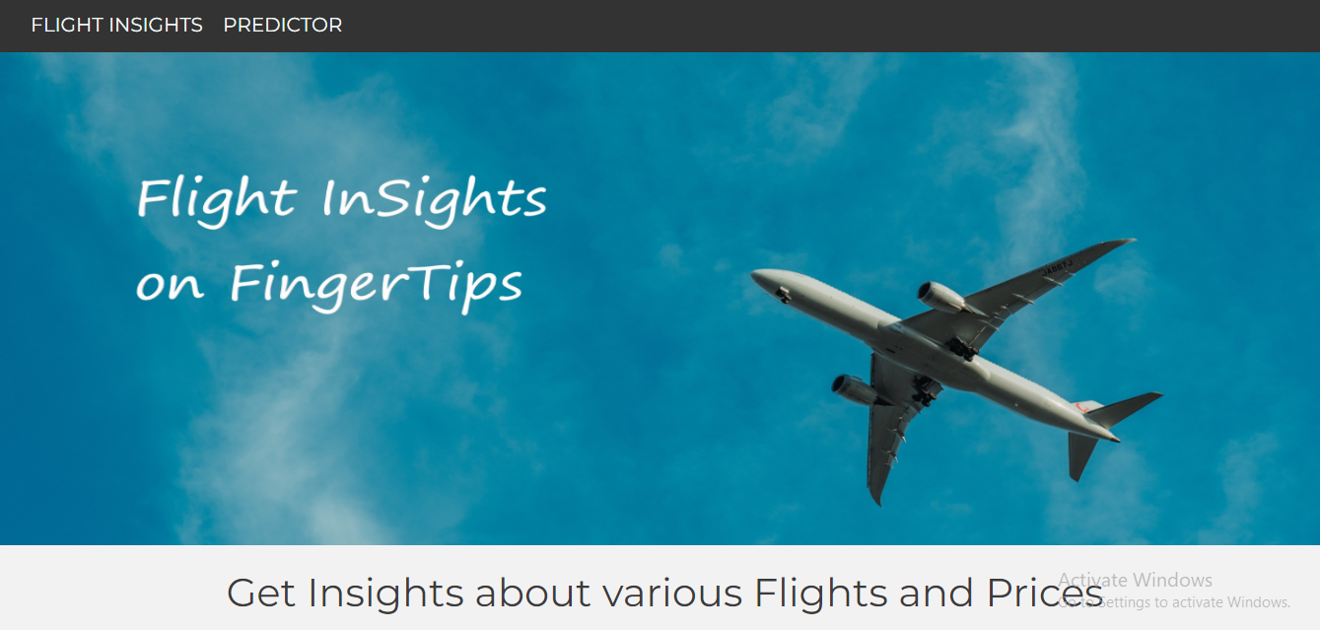

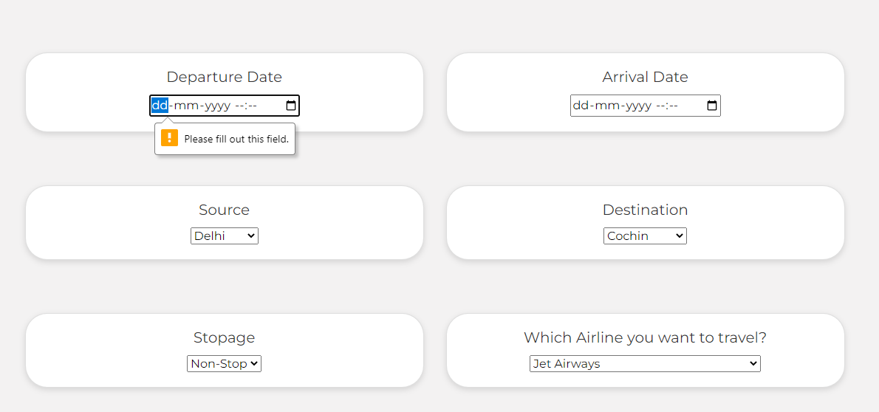

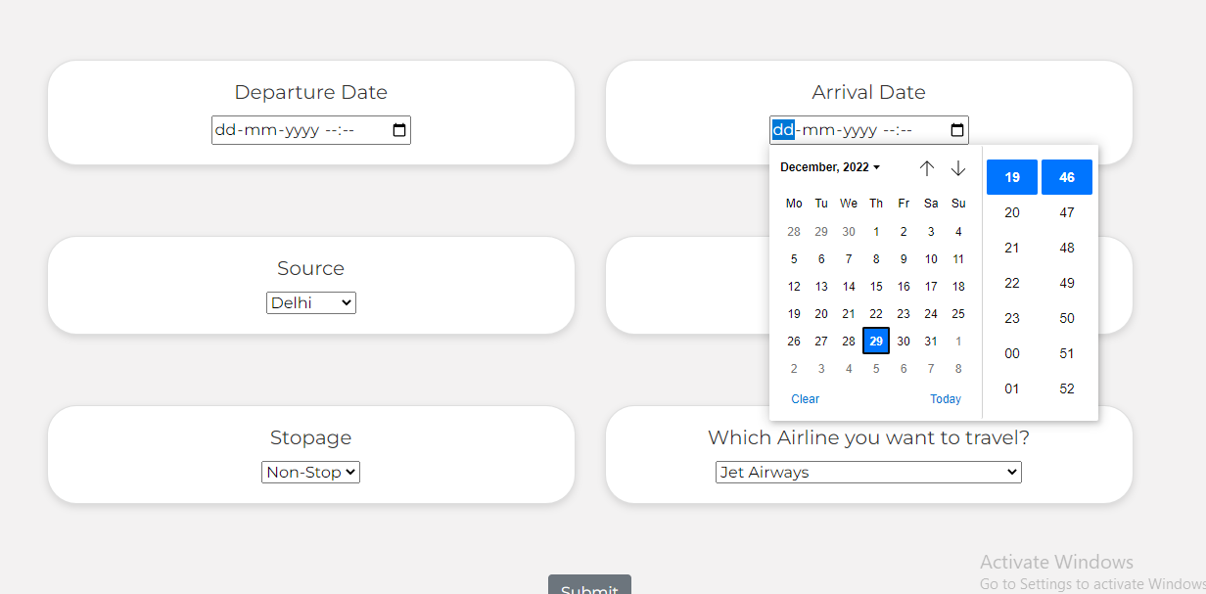

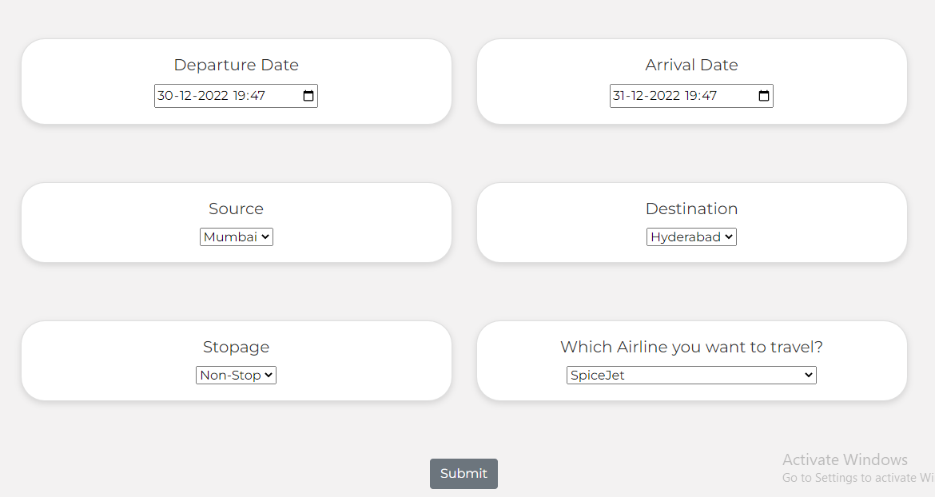

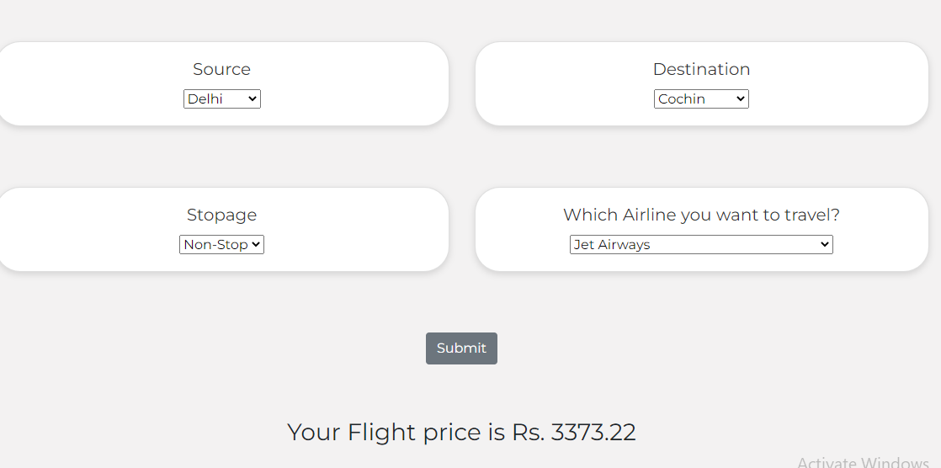

**CONCLUSION AND FUTURE SCOPE:**

This System customer can predict the flight price of a particular seat on a day before booking the flight tickets. It will provide an ease to the customer for the flight ticket booking. Travelers can save money if they choose to buy a ticket when its price is the lowest. The problem is how to determine when is the best time to buy flight ticket for the desired destination and period.

From our thorough analysis of each of the 18 routes, we can define the following. Flight prices almost always remain constant or increase between the major cities. Tourist routes that offer services involving Tier-2 cities of the country have uneven treads related to the increase and decrease of airline ticket prices. Routes with data collected over a longer duration of time tend to facilitate much more accurate predictions in the model and thus lead to higher average savings.

More routes can be added and the same analysis can be expanded to major airports and travel routes in India. The analysis can be done by increasing the data points and increasing the historical data used that will train the model better giving better accuracies and more savings. More rules can be added to the Rule-based learning based on our understanding of the industry also incorporating the offer periods given by the airline. Developing a more user-friendly interface for various routes giving more flexibility to the users.

# CHAPTER 6 REFERENCES:

# <https://youtu.be/Z1RJmh_OqeA>

# <https://youtu.be/J4Wdy0Wc_xQ>

# [1] Bachis, E., & Piga, C. A. (2011). “Low-cost airlines and online price dispersion. International Journal of Industrial Organization”, 29(6), 655– 667. doi:10.1016/j.ijindorg.2011.02.006

# [2] Groves, W. and Gini, M., 2021. “A Regression Model For Predicting Optimal Purchase Timing For Airline Tickets.”. Available at: https://conservancy.umn.edu/handle/11299/215872

# [3] T. Wohlfarth, S. Clemencon, F. Roueff and X. Casellato, "A Data-Mining Approach to Travel Price Forecasting," doi: 10.1109/ICMLA.2011.11.

# [4] T. Wang et al., "A Framework for Airfare Price Prediction: A Machine Learning Approach," doi: 10.1109/IRI.2019.00041.

# [5] V. H. Vu, Q. T. Minh and P. H. Phung, "An airfare prediction model for developing markets," doi: 10.1109/ICOIN.2018.8343221